# Tab 2



Ward_Type, Ward_Facility_Code

C

D E

F A

D B

C A F A

B F E C D E

B B F

C E

D A F

# Tab 1

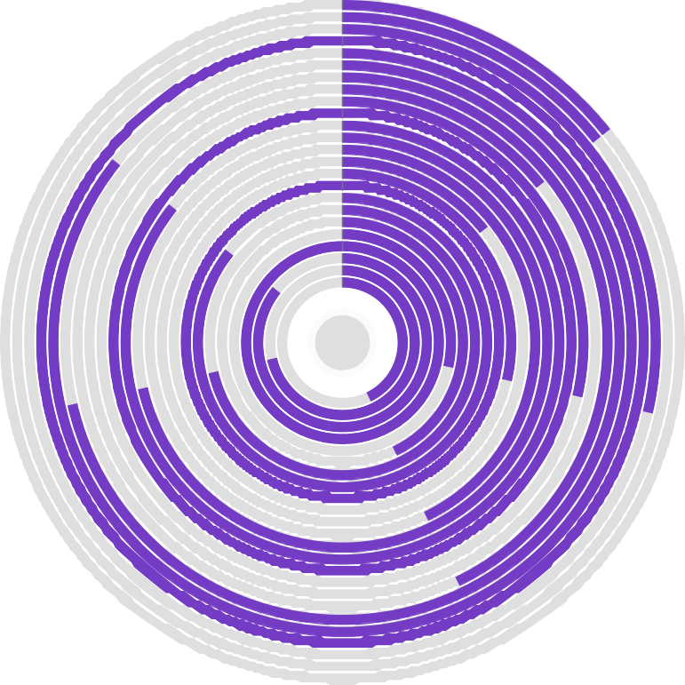

Hospital_type_code by Bed Grade and Ward_Type